Virpobe Paireepinart
CS 5338 / 3378 Formal Languages / Theory of Automata
Fall 2009
Assignment 5 (100 points, Chapters 11, 12)
Due: Nov 10, 09, Tuesday, hard copy in class, *.jff files to TRACS

- (20) Let Σ = {a, b}. For the languages that are defined by each of the following grammars, do each of the following:
i. List five strings that are in L.
ii. List five strings that are not in L.
iii. Describe L concisely. You can use regular expressions, expressions using variables (e.g., a^{n}b^{n}, or set theoretic expressions (e.g., {x: …})
iv. Indicate whether or not L is regular. You do not need to provide a proof.

- S → aS | Sb | ε
In L:
ab
aab
aaab
abbbb
aaabbb

Not in L:
bbbaaa
bababa
baaaa
babbbbbb
bbba

Regex:
a*b*

L is regular.

- S → aSa | bSb | a | b
In L:
aaa
aaaaa
bbb
bab
babab

Not in L:
aa
aaaa
bb
bbbb
baa

Description: {x: x is an odd-length string that is symmetric about the center}

L is not regular

- S → aS | bS | ε
In L:
a
{}
ababab
aaaaaa
bbbbbb

Not in L:
This grammar generates every possible string in our language, so there are no strings that are not in L.

Description: {a, b}* (kleene star of our language)

L is regular

- (0) Let G be the grammar of Example 11.12 (Page 220 on text) . Show a third parse tree that G can produce for the string (())().

S

S S S

( S ) ( S ) ε

( S ) ε

ε

- (20) Consider the following grammar G: S → 0S1 | SS | 10
Show a parse tree produced by G for each of the following strings:

- 010110
- 00101101

S S

S S 0 S 1

0 S 1 1 0 S S

1 0 0 S 1 1 0

1 0
- (30) Show a context-free grammar for each of the following languages. For each grammar, create *.jff with the given file name and submit to TRACS, then copy the grammar in *.jff below. Note that (a) ~ (h) have corresponding subquestions in Question 5.

- BalDelim = {w : where w is a string of delimeters: (, ), [, ], {, }, that are properly balanced}.

S→ (S) | [S] | {S} | ε

- {a^{i}b^{j} : 2i = 3j + 1}.

S →aA
A → aaaAbb | ε
- {w ∈ {a, b}* : #_{a}(w) = 2 #_{b}(w)}.

S →aaSb
S →bSa
S →SS
S →aSab
S →aSba
S →baSa
S →bSaa
S →ε

- {w ∈ {a, b}* : w = w^{R}}.

a string equal to its inverse is just a palindrome.
S→ aSa
S→ bSb
S→ ε

- {w ∈ {a, b}* : every prefix of w has at least as many a’s as b’s}.

S→aS
S→abS
S→baS
S→ε

- {a^{n}b^{m} : m ≥ n, m-n is even}.

S → aSb | Sbb | ε

- {xc^{n} : x ∈ {a, b}* and (#_{a}(x) = n or #_{b}(x) = n)}.

S→ A | B
A → B′ a B′ A c | B′
B′ → bB′ | ε
B → A′ b A′ B c | A′
A′ → aA′ | ε

- {b_{i}#b_{i+1}^{R} : b_{i} is the binary representation of some integer i, i ≥ 0, without leading zeros}. (For example 101#011 ∈ L.)

L can be written as:
0#1 ∪ {1^{k}#0^{k}1 : k > 0} ∪ {u01^{k}#0^{k}1u^{R} : k ≥ 0 and u ∈ 1(0 ∪ 1)*}
So a grammar for L is:
S → 0#1 | 1 S₁ 1 | 1 S₂ 1
S₁ → 1 S₁ 0 | #0
S₂ → 1 S₂ 1 | 0 S₂ 0 | 0 A 1
A → 1 A 0 | #

- (30) Build a PDA to accept each of the following languages. For each PDA, first use a sextuple to define it. Then, create *.jff with the given file name and submit to TRACS. Then, cut and paste the figure in *.jff below. The sample solutions may not contain both forms of the PDA definitions. However, you should do both. Note that (a) ~ (h) have corresponding subquestions in Question 4. This does not mean you can use JFLAP to automatically convert the grammars in Question 4 to corresponding PDAs because the definition of PDA in JFLAP is different from the one we use.

- BalDelim = {w : where w is a string of delimeters: (, ), [, ], {, }, that are properly balanced}.
M = (
States: (q0),
Input alphabet: { (, ), [, ], {, } },
Stack alphabet: { ), ], } },
initial state q0,
accepting states q0,
transition relation:
((q0, (, ε), (q0, ‘)’)),
((q0, ), ‘)’), (q0, ε)),
((q0, [, ε), (q0, ])),
((q0, ], ]), (q0, ε)),
((q0, {, ε), (q0, {)),
((q0, }, }), (q0, ε)))

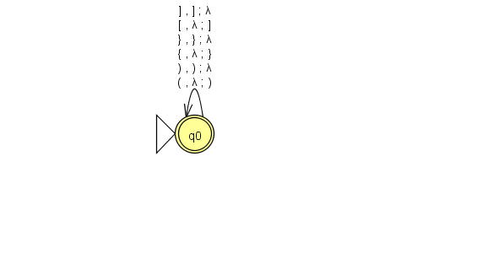

- {a^{i}b^{j} : 2i = 3j + 1}.
M = (
States: (q0, q1),
Input alphabet: { a,b },
Stack alphabet: { a },
initial state q0,
accepting states q1,
transition relation:
((q0, a, ε), (q0, aaa)),
((q0, b, a), (q1, ε)),
((q1, b, aa), (q1, ε)))

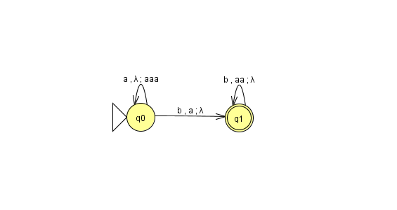
- {w ∈ {a, b}* : #_{a}(w) = 2⋅#_{b}(w)}.
M = (
States: (q0, q1, q2),
Input alphabet: { a,b },
Stack alphabet: { a },
initial state q0,
accepting states q2,
transition relation:
((q0, b, ε), (q1, ε)),
((q0, a, ε), (q1, aa)) ,
((q1, b, a), (q2, ε)),
((q1, a,e), (q2, aa)),
((q2, b, a), (q2, ε)),
((q2, a, ε), (q2, aa)))
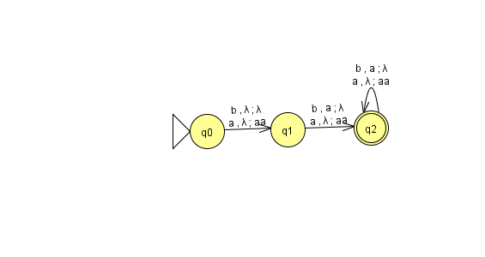

- {w ∈ {a, b}* : w = w^{R}}.

- {w ∈ {a, b}* : every prefix of w has at least as many a’s as b’s}.
M = (
States: (q0, q1),
Input alphabet: { a,b },
Stack alphabet: { a },
initial state q0,
accepting states q1,
transition relation:
((q0, b, a), (q0, ε)),
((q0, a, ε), (q0, a)) ,
((q0, ε, a), (q1, ε)))

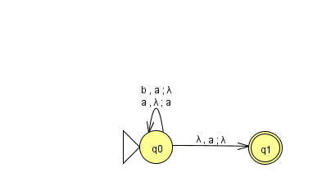

- {a^{n}b^{m} : m ≥ n, m-n is even}.

M = ({1, 2, 3, 4}, {a, b }, {a}, Δ, 1, {3}), where Δ =
{ ((1, a, ε), (1, a)),
((1, b, a), (2, ε)),
((1, ε, ε), (3, ε)),
((2, b, a), (2, ε)),
((2, ε, ε), (3, ε)),
((3, b, ε), (4, ε)),
((4, b, ε), (3, ε)) }

- {xc^{n} : x ∈ {a, b}*, #_{a}(x) = n or #_{b}(x) = n}.

M will guess whether to count a’s or b’s. M = ({1, 2, 3, 4}, {a, b, c}, {c}, Δ, 1, {1, 4}), where Δ =
{ ((1, ε, ε), (2, ε)),
((1, ε, ε), (3, ε)),
((2, a, ε), (2, c)),
((2, b, ε), (2, ε)),
((2, ε, ε), (4, ε)),
((3, a, ε), (3, ε)),
((3, b, ε), (3, c)),
((3, ε, ε), (4, ε)),
((4, c, c), (4, ε)) }

- {b_{i}#b_{i+1}^{R} : b_{i} is the binary representation of some integer i, i ≥ 0, without leading zeros}. (Example: 101#011 ∈ L.)

M = ({0, 1, 2, 3, 4, 5, 6, 7}, {0, 1, #}, {0, 1}, Δ, 0, {3, 4, 7}), where Δ =
{ ((0, 1, ε), (1, 1)), /* The normal case, where w starts with a 1.
((0, 0, ε), (5, ε)), /* The special case of the string 0#1.
((1, 0, ε), (1, 0)), /* Push 0’s and 1’s until the # is read.
((1, 1, ε), (1, 1)), ″
((1, #, ε), (2, ε)), /* At the #, go to state 2 and start popping.
((2, 0, 1), (2, ε)), /* First half had 1. So this 0 is creating a carry bit.
((2, 1, 0), (3, ε)), /* Reading the 1 that replaces a 0.
((2, 1, ε), (4, ε)), /* If the first half is 1*, then this is the 0 that starts the second half.
((3, 0, 0), (3, ε)), /* Handling the part after the 1 got added. All chars must match.
((3, 1, 1), (3, ε)), ″
((5, #, ε), (6, ε)), /* A little FSM to finish reading 0#1.
((6, 1, ε), (7, ε)) } ″

- L₁*, where L₁ = {xx^{R}: x ∈ {a,b}*}.

M = ({1, 2, 3, 4}, {a, b}, {a, b, #}, Δ, 1, {4 }), where Δ =
{ ((1, ε, ε), (2, #)),
((2, a, ε), (2, a)),
((2, b, ε), (2, b)),
((2, ε, ε), (3, ε)),
((3, a, a), (3, ε)),
((3, b, b), (3, ε)),
((3, ε, #), (4, ε)),
((3, ε, #), (2, #)) }

- {a^{n}b^{m} : m ≤ n ≤ 2m}.

M = ({1, 2}, {a, b}, {a}, Δ, 1, {1, 2}), where Δ =
{ ((1, a, ε), (1, a)),
((1, ε, ε), (2, ε)),
((2, b, a), (2, ε)),
((2, b, aa), (2, ε)) }.

- {a^{n}b^{m}a^{n} : n, m ≥ 0 and m is even}.

file name: a5-5k.jff (in JFLAP, use finite state acceptance)

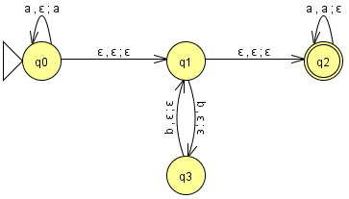
- (10 bonus) The definition of PDA in JFLAP is different from ours. However, you can manage to run and test the PDAs built for Question 5, (a) ~ (e). Describe how.

Hint 1: which acceptance option to use, finite state or empty stack?

Hint 2: for some of them, simplying choosing an acceptance option wouldn’t work. You may need to modify the original PDA.

